CS 340 README

About the Project
This project uses Python’s MongoDB Driver to connect to a MongoDB server locally hosted on port 27017. This project relies on a CRUD Python Module which has create, read, update, and delete capabilities. This project is a dashboard that shows the user information about the Austin Animal Care

Motivation
A dashboard display allows for better visualization of the underlying database. The user can visualize the break down of different breeds depending on predefined filters, and can see the location of a selected animal on the map. This allows for the reading of the Austin Animal Care database without calls to specific pymongo methods and objects. Allowing for a front-end application to interface with the underlying MongoDB instance.

Getting Started
To get a local copy up and running, make sure to follow these steps
- enable user authentication in the mongoDB server
- start the mongodb server by using the ```mongod``` command
- ensure that your mongodb server has a database named AAC
- ensure that the AAC database has a collection named animals
- ensure that you have a user called “accuser” with permissions to read and write to the AAC database
```JavaScript
db.createUser(
{
user: "aacuser",
pwd: passwordPrompt()
roles: [ { role: "readWrite", db: "AAC"} ],
})
```
- ensure that the username and password in the animal_shelter.py file reflects your chosen credentials
- go to the supplied jupyter notebook file and click the “Kernel” tab then click the “Restart & Run All” option
Tips
- the CRUD methods of the python module rely on using an authenticated user who’s credentials are sent to the init method, specifically, the MongoClient constructor.
- Challenges include improper formatting of credentials that have reserved lettering such as @. MongoClient defaults to admin authSource, so a user with permissions just for the AAC database can be invalidated. Passing the credentials arguments directly into the constructor as kwords eliminates the need to construct a URI with a specified authSource and import packages to deal with reserved letters.
- A challenge when running the dashboard includes restarting the kernel to ensure that changes made to the IPYNB file is reflected when you open port 8050 where the web application runs
- Ensure that the MongoDB server is running before using the web application, otherwise, the model cannot be queried from the database.
- When first loading the dashboard, it will prompt you to select a row so that the map and pie chart can show the correct information
- The data table supports finer grain filtering
Info
- The dashboard serves as a Model View Controller (MVC) to the Austin Animal Center database
- The Model is the MongoDB database and is where the animal data resides.
- Dash is a Python framework that enables the Viewing of data through web dashboards
- Dash has interactive components that can be used to control the Model.
- With this in mind, PyMongo allows for interfacing with the MongoDB database model through Python, thus allowing for Dash to interface with the database through a controller.
- This Dashboard was made to serve the interest of Grazioso Salvare, thus there are special filters to isolate potential candidates for a specific training. For example, German Shepherds are preferred for Mountain Rescues.
- Due to the way dog breeds are stored, there is a potential for a dog to be of two potential breeds, and similar breeds may also be shown to allow for more animals to be seen in the search.

Installation
There are a few tools needed to use this software
- [Python](https://www.python.org/downloads/)
  - needed to use the CRUD Module
- [Jupyter Notebook](https://jupyter.org/install)
  - needed to run the IPYNB file
- [MongoDB Version 6.0](https://www.mongodb.com/docs/manual/installation/)
  - needed to use the version 6.0+ local MongoDB server
- Optional: [Docker](https://www.docker.com/products/docker-desktop/)
  - an optional environment to set up the local MongoDB server

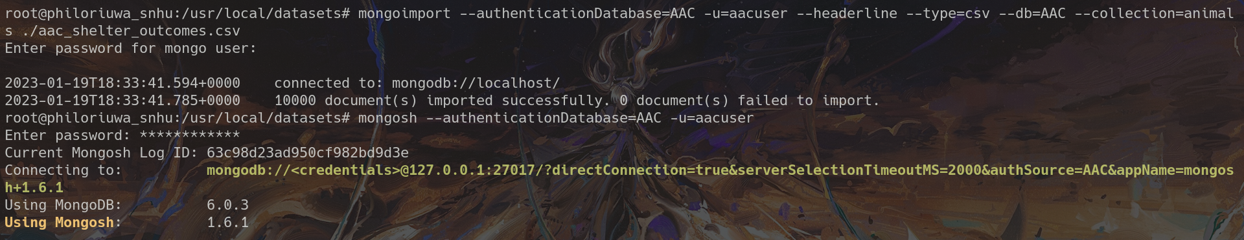
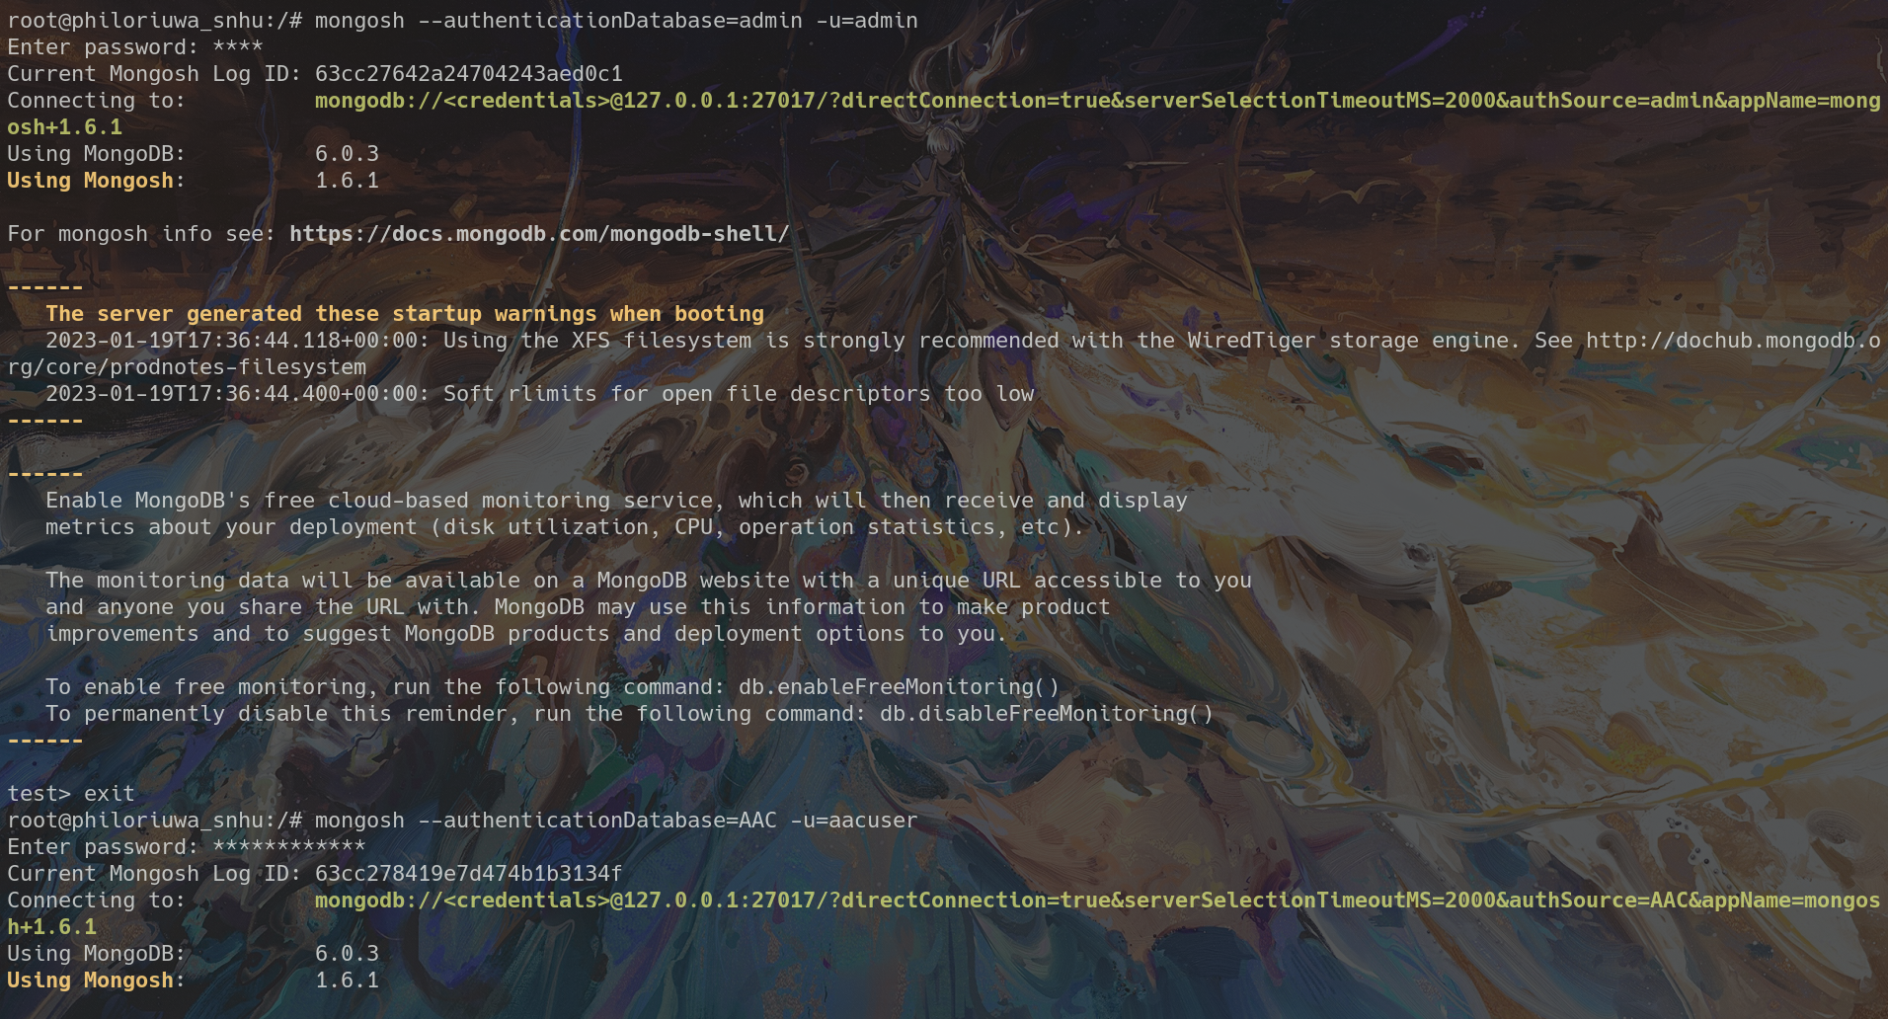
Screenshots
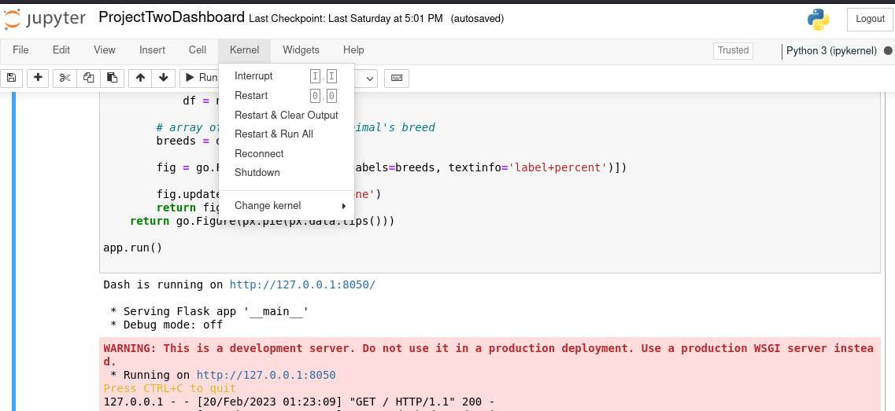
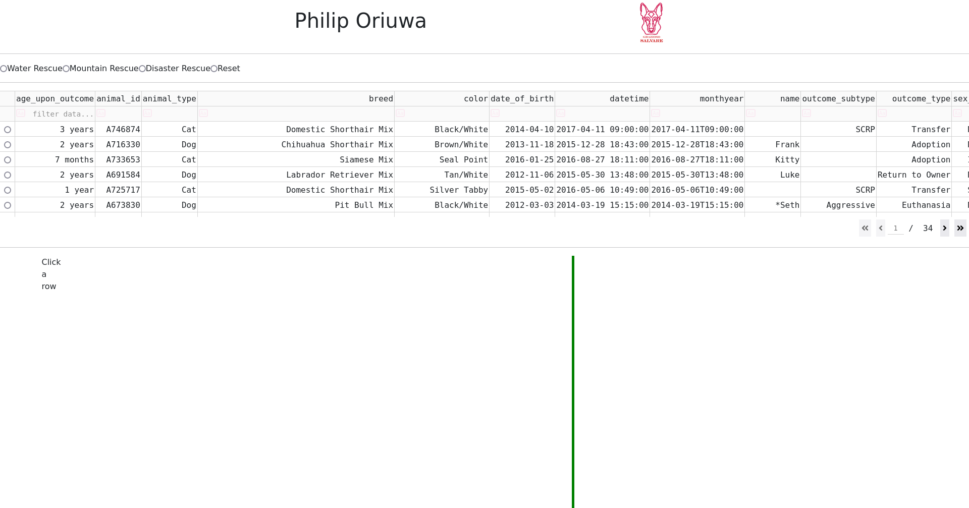
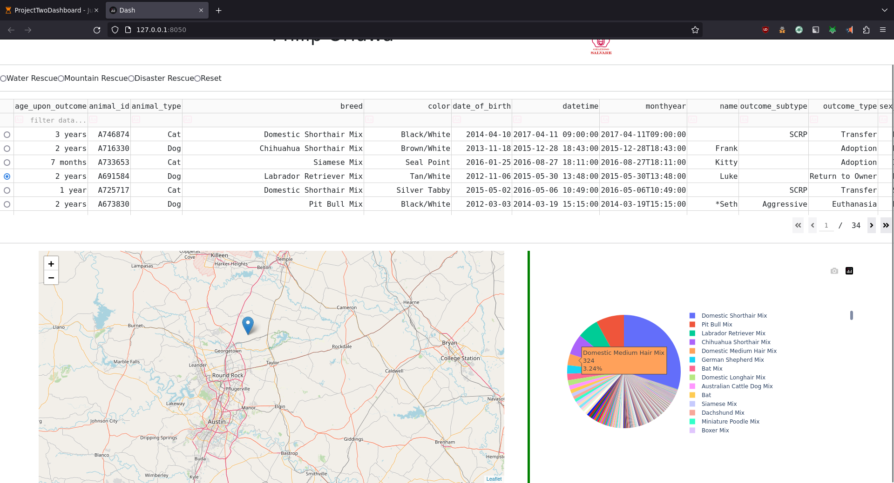
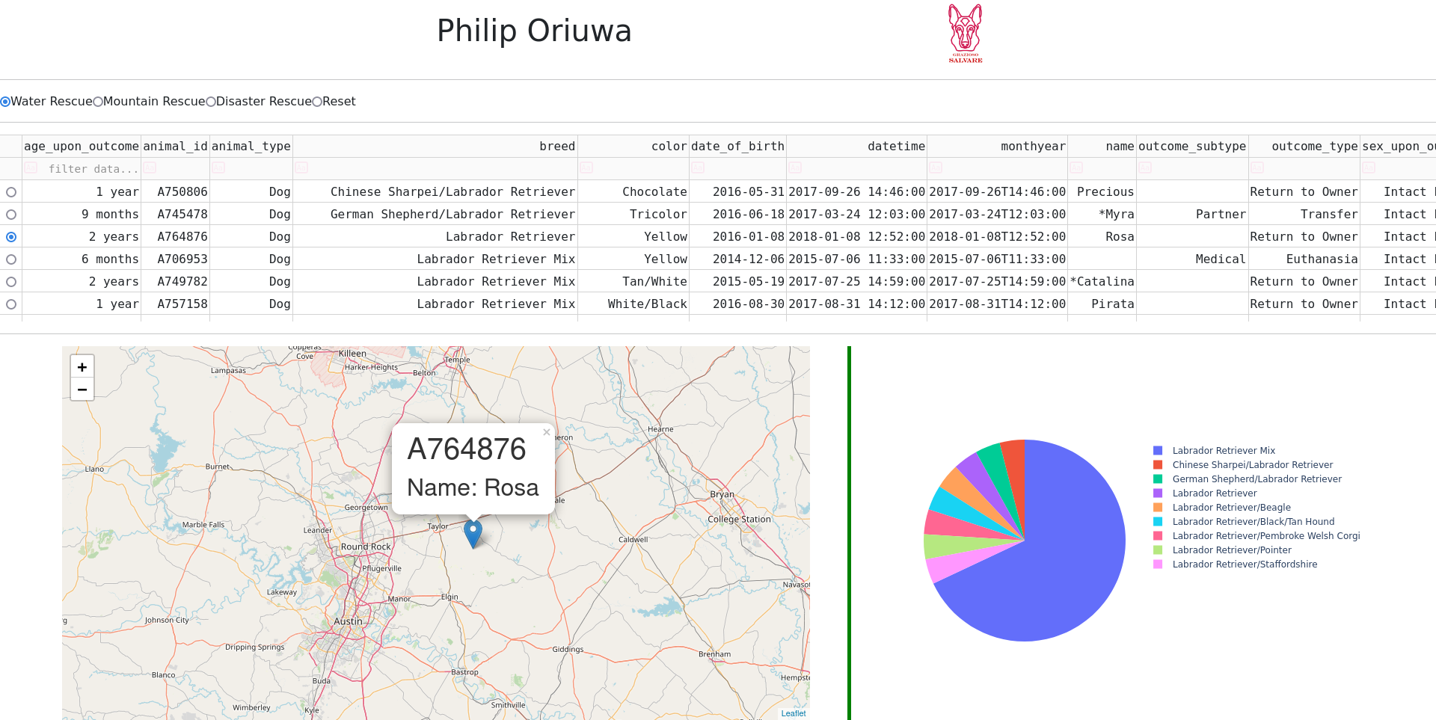
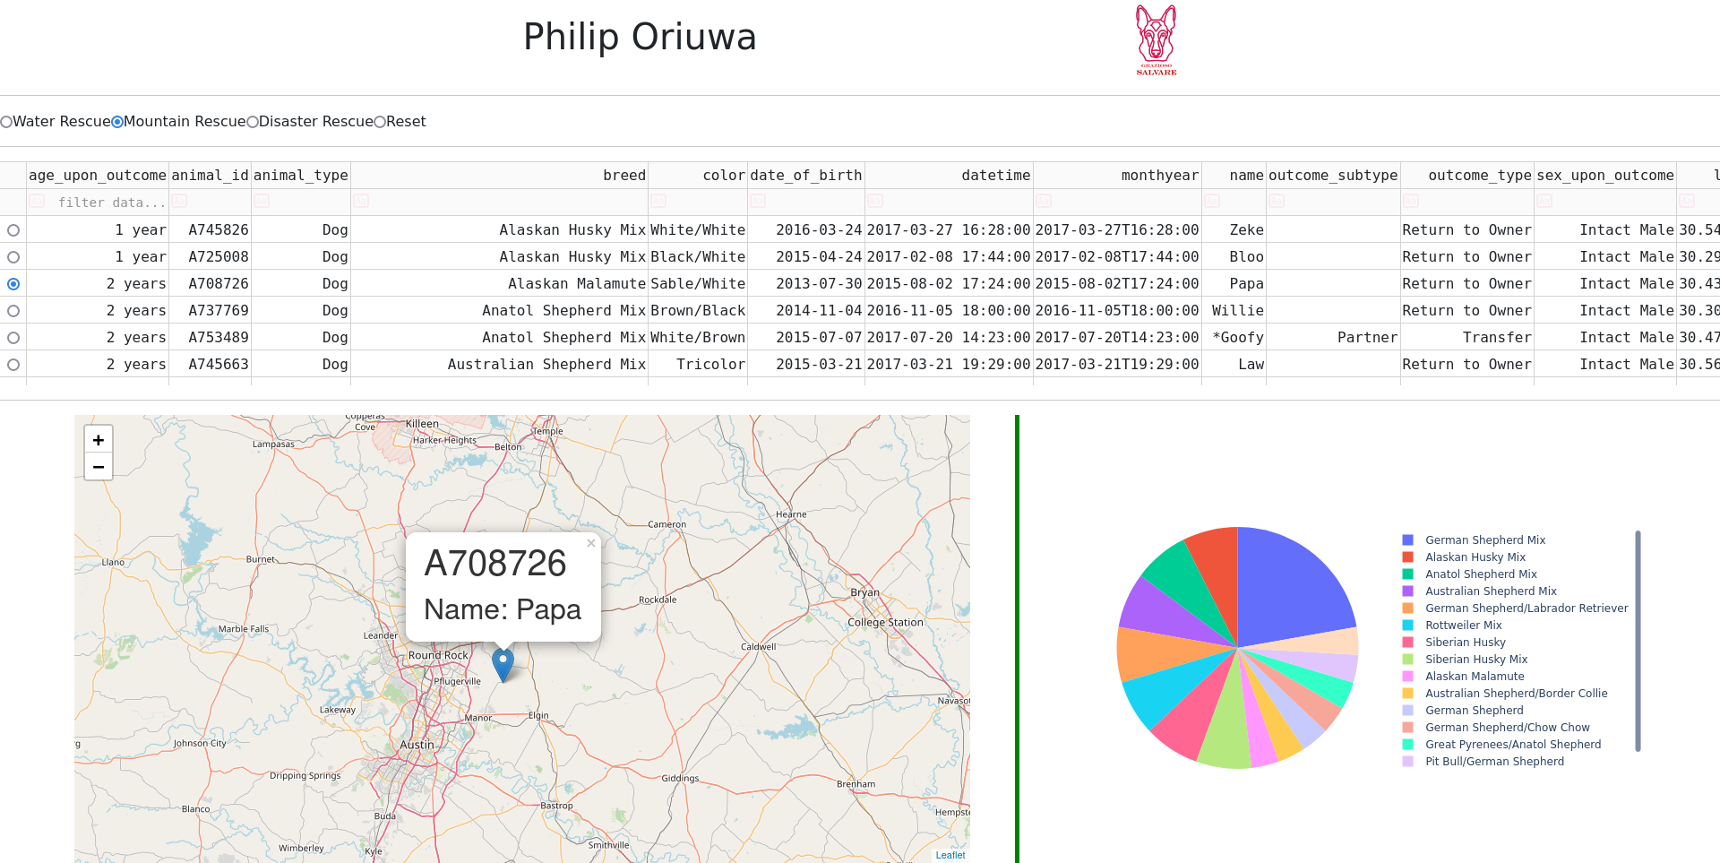
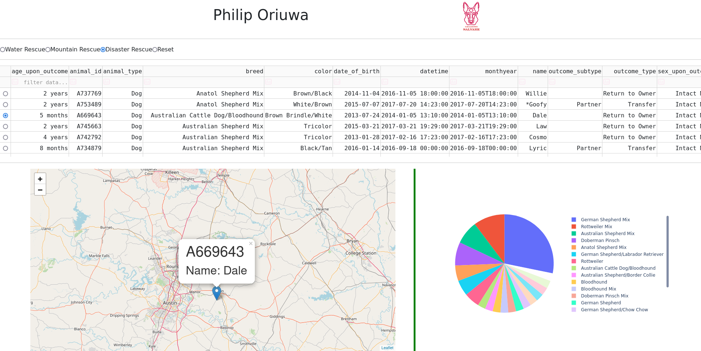
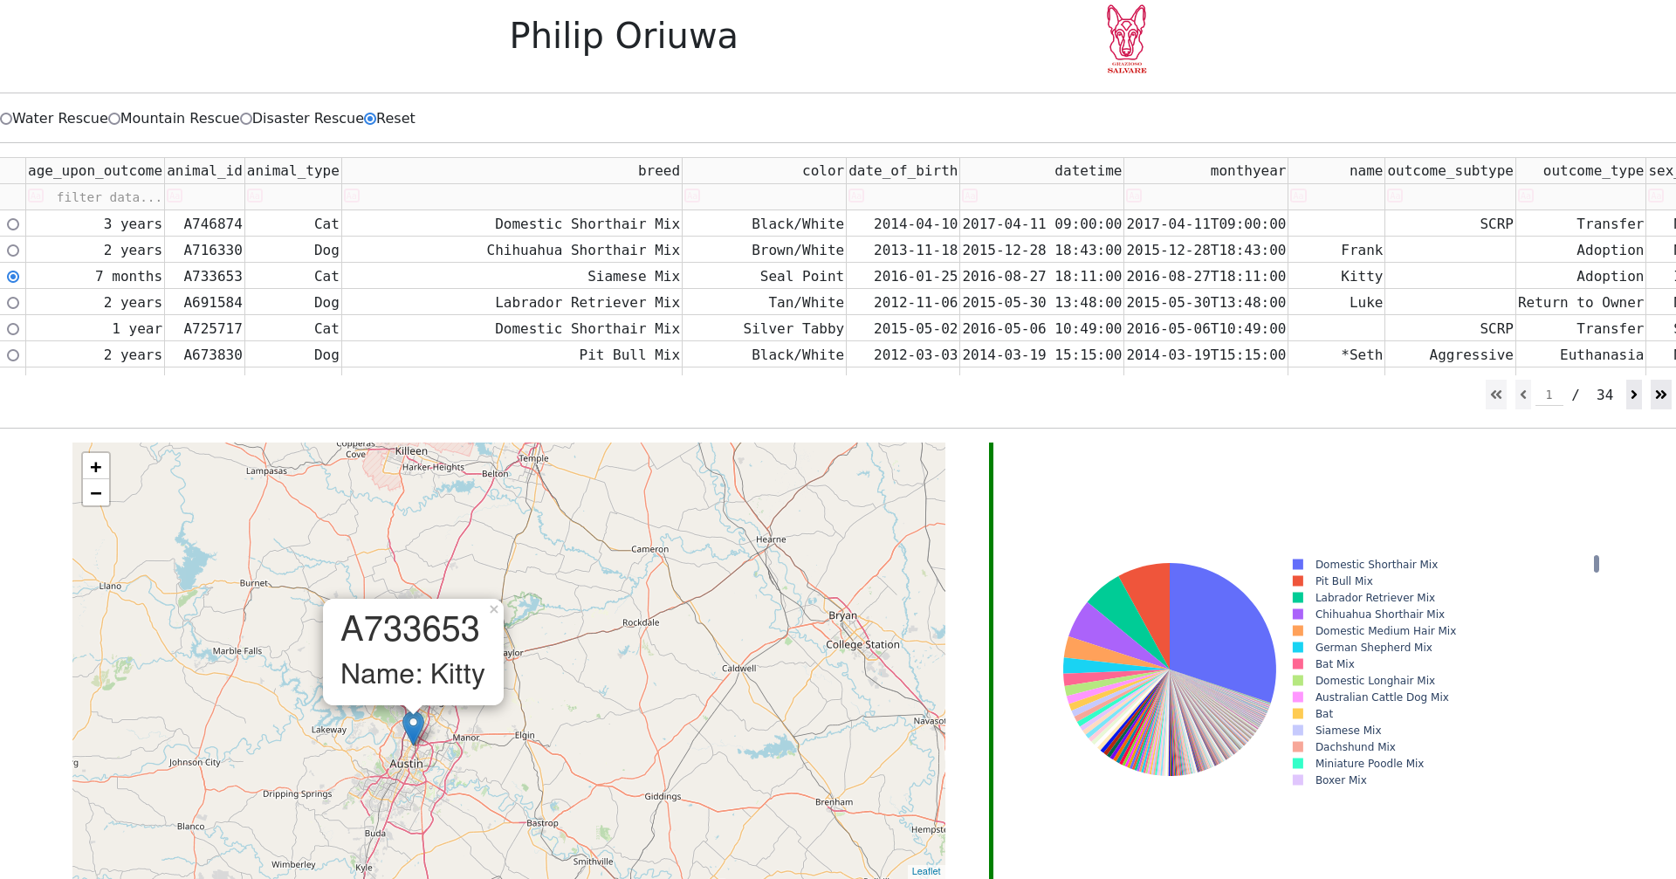

Contact
Philip Oriuwa

